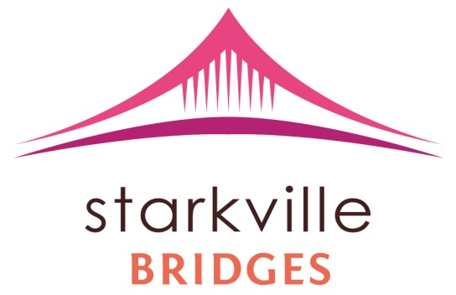
Steering Committee Meeting
July 10, 2014
Queen Brown
Present: John Breazeale, Rod Holmes, G.E. Light, Ruth Brown, Nikki Rives, Beverly Hammett, Queen Brown
- Meeting began at 11:00 a.m.
- Meeting opened discussing the promotion of the One Day Community Training and the Facilitators Training
- George Light has to PSA (Public Service Announcements) running daily through Mississippi State University Radio Station WMSV.
- Beverly Hammet brought up promoting through the First United Methodist Church, WCBI, WLZA, the Starkville Daily Newspaper, The Dispatch, Oktibbeha County Hospital bulletin, SuperTalk MS with Jim Ellis, MVC (Maroon Volunteer Center), Volunteer Starkville, and of course to continue spreading the word through our individual communities, churches, agencies, and neighbors.
- Both radio and newspaper features will consist of a two part spread. First, generally discussing Starkville Bridges and what it is and what it is for. Second, would be specifically about the trainings in the fall.
- The Starkville Bridges 2014 Summer Flyer will continue to be advertised throughout the city and, Beverly, suggested putting it in the library (both the city’s and Mississippi State’s); the flyer is attached in the e-mail as well so please do share with your own communities, churches, agencies, and neighbors.
- Update on the Trainings
- John is still waiting to hear back from the Stennis Center, who will be providing the writing utensils and essentials, such as, paper and folders
- The Sportsplex will provide tables and chairs
- Coffee and donuts will be provided for breakfast/ Little Dooey will cater lunch
- Anyone may register through the website, www.starkvillebridges.com
- We are exactly two months away from the trainings; tasks will be sorted amongst everyone at the next Steering Committee Meeting
- Note: Everyone affiliated with Starkville Bridges has to go through training; $50 for training
- Lynn Phillips-Gaines, previously, suggested that everyone, including those who are already Facilitators, attend the training for a refresher
- Wine Tasting Fundraiser will begin to be planned for the Spring
- BB4K end date has been pushed up to this Friday July 18, 2014
- There will be a graduation of sorts and fun games and awards for the participants
- 1:00-3:30 p.m.
- National Bridges Conference
- October 6-7, 2014, a Tuesday and Monday, in Nashville, TN
- Note: the next Steering Committee meeting will be August 14th

Adjourned: 11:45 a.m.

