  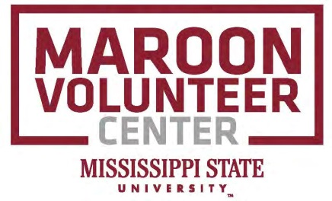

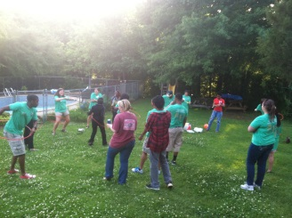 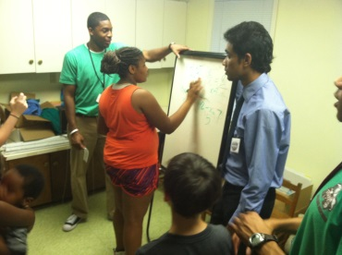 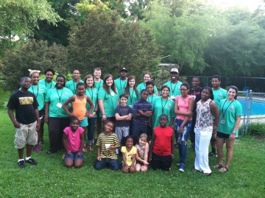

**Building Bridges for Kids Mentors Needed this Summer at the Boys and Girls Club!**

**June 2 – August 4, 2014**

**Mentors should be:**

*Available **Monday and Wednesdays; 1:00pm to 3:30pm**

*Enjoy working with Children grades 3rd-5th

*Able to attend the Mentor Training in May

*Positive Attitude

*Must be available over the Summer

*Committed to this program and its purpose

***For more information about this program and its responsibilities,***

***Contact Rod Holmes at rh108@saffairs.msstate.edu and/or (662) 325-1821***

