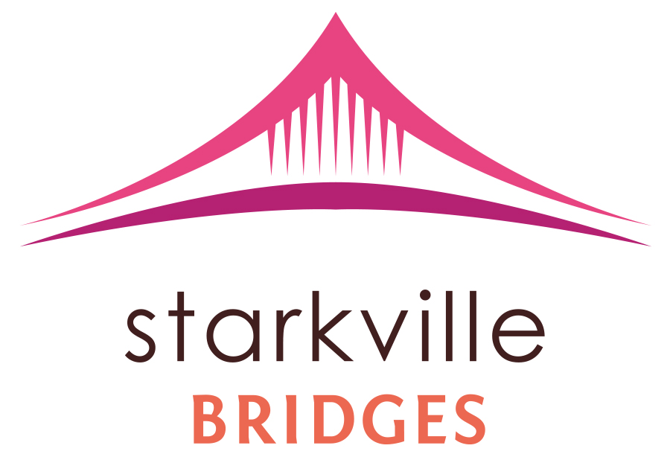  Newsletter  Summer 2014
  Starkville Bridges
The 2013 Getting Ahead Class

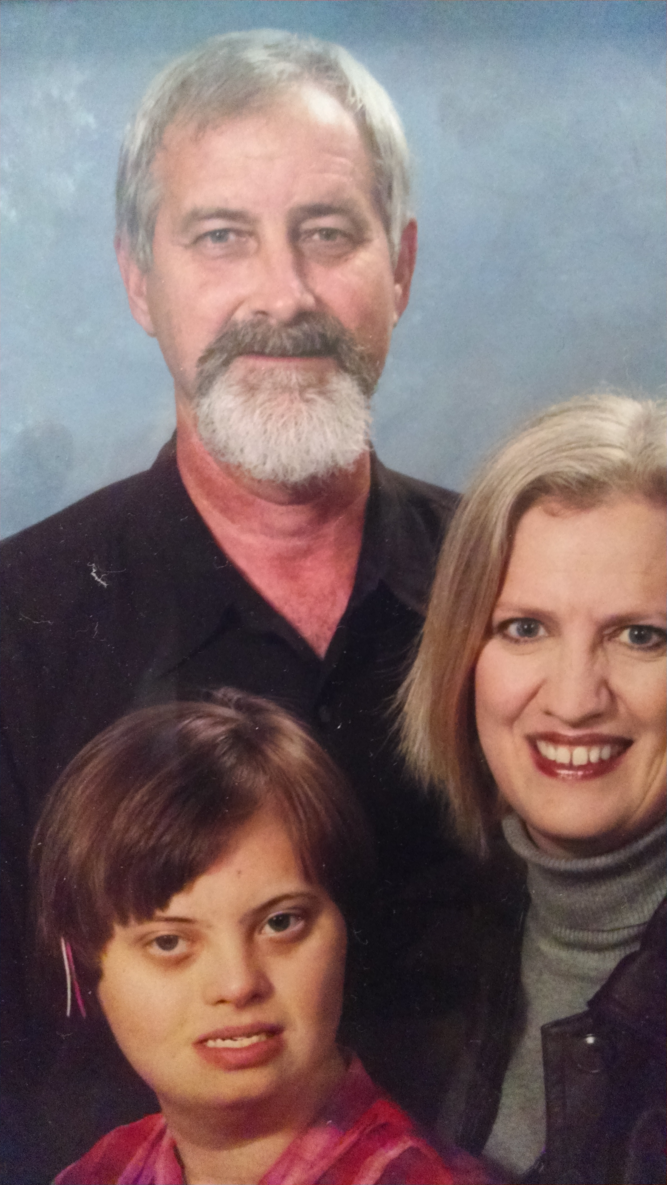
been in this position since 2000. Then in 2011, John decided to become even involved in the community by becoming a part of the Steering Committee for the new community project, Starkville Bridges which is inspired from the book, Bridges Out Of Poverty: Strategies for Professionals and Communities, written by Ruby K. Payne, Phillip E. Devol, and Terie Dreussi Smith. Mrs. Lynn Phillips-Gaines founded this initiative and was the first Board of Directors President.

Mr. John Breazeale is a native of Shaw, Mississippi. He left Shaw to study at Mississippi State University. John studied Philosophy at MSU. After his studies, John decided to remain in Oktibbeha County, and has been a resident since 1980.
He is a member of University Baptist Church and the Starkville Civitan Club. He is the Construction Supervisor for the Starkville Area Habitat for Humanity. John has

New Year, New Changes

John Breazeale, President of the Board

John remained on the Steering Committee until he became a chartered member of the Board of Directors. John became a trained facilitator and taught his own Getting Ahead class in the year 2013. Because of his intensive involvement in Starkville Bridges it was no surprise when John became the President of the Board beginning in the year of 2014. While presiding over Starkville
Bridges, John is still maintains his job as the Construction Supervisor of Habitat for Humanity; nonetheless, it is safe to say, John is hardworking and dedicated to eradicating poverty and helping the Starkville community.
John is married to Linda Moore Breazeale and together they have one daughter, Debra Ann Breazeale.
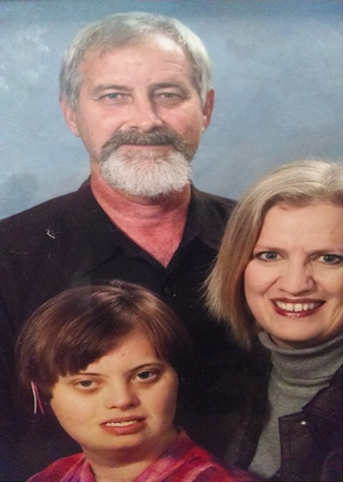

Founder and Former President, Lynn Phillips-Gaines 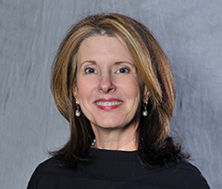

including the Phillips Financial Habitat Classic. In 2013, Lynn was recognized as “Woman of the Year” by Starkville Daily News. She also received the T.E. Veitch Community Service Award and the 2013 Rotary Community Service Award.
Due to the success of these endeavors and the overwhelming support from volunteers, Lynn felt her community would further benefit from having a staff that was devoted solely to the program. Lynn’s last duty as the President of the Board of Directors was to put together a strategic planning meeting, during which goals were set for Starkville Bridges for the next three years.

and testing to become a Certified Trainer for the Bridges out of Poverty program and then brought together key stakeholders of the community, which formed the Starkville Bridges Steering Committee.

Since inception of the initiative, Starkville Bridges out of Poverty has held three Getting Ahead in a Just Getting by World Facilitator Classes. From these classes, another program, Building Bridges for Kids (BB4K), was formed. In addition to these classes, Lynn organized and hosted two Summer Soiree Fundraisers. Aside from Bridges out of Poverty, Mrs. Lynn Phillips-Gaines has been involved in numerous charities and community projects over the years,

Lynn Phillips-Gaines, Certified Financial Planner of Phillips Financial and Registered Principal of Raymond James Financial Services, Inc., founded Starkville Bridges out of Poverty in the year 2011. She served as President of the Board of Directors from 2011 until January 2014.
Realizing the need for an anti-poverty program in her community, Lynn’s first step was to further educate herself. She completed course work

Farewell from Lynn
Thank you to everyone who helped make Starkville Bridges a reality in our community. I cannot even hazard a guess at the number of volunteer hours that have gone into this initiative since it was founded in June 2011. All involved should be proud of the progress our initiative has accomplished in its brief life!
It was an honor to work with everyone that has been a part of Starkville Bridges. I’ve turned over leadership into the capable hands of John Breazeale. John has been involved with this program since the beginning, has served as a charter board member, and I believe he has the heart for this type of initiative. John has served as President of the Board of Directors since January 17, 2014. I cannot express enough how rewarding it’s been to see the community work together and take ownership of Starkville Bridges. My heartfelt thanks go out to those of you who have stepped up to serve

in leadership positions within the organization, and I eagerly await the wonderful things you will accomplish in the future!

Starkville Bridges Welcomes

Queen Brown joins Starkville Bridges as Student Worker

Starkville Bridges is happy to announce Queen Brown as its student worker/Assistant!
Queen was welcomed to our organization in early 2014. She is a junior at Mississippi State University, and a double major. Her primary major is Political Science, with a concentration in Pre-Law, and her secondary major is Philosophy. Queen is highly involved on campus as well, serving as the Hospitality Chair for the MSU branch of the NAACP, Community Service Chair of Gamma Beta Phi Honor

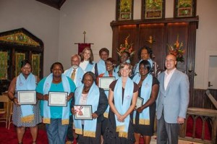
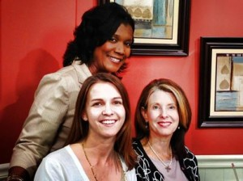
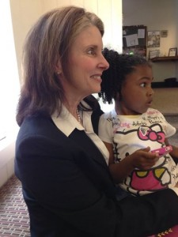
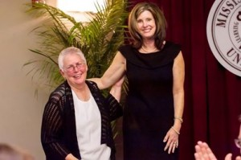
A BB4K kid with the Reverend Lynn Phillips-Gaines
Lynn Phillips-Gaines and the Starkville Bridges Donor of the Year, former alderwoman Sandra Sistrunk

Starkville Bridges Promoting Summer Soiree on WCBI with Andrea Self

Starkville Bridges Third Getting Ahead in a Just Gettin’ by World Class Graduation

Society and Phi Sigma Pi National Honor Fraternity, and as the Outreach Coordinator of I.D.E.A.L Woman. She has previous experience volunteering at Starkville Area Habitat for Humanity, Starkville Church of God Food Pantry, Starkville Boys and Girls Club, and many other community agencies around the Starkville area. Queen loves volunteering and is always interested in community service and helping others in any way possible.
We are pleased to have Queen Brown as our newest addition!

Starkville Bridges
Welcomes New 2014
Board Positions:

President of the Board: John Breazeale

Vice President: Taylor Adams

Board member: Spencer Broocks
Starkville Bridges Summer 2014

Building Bridges for Kids
BB4K is a spin-off program from Starkville Bridges that focuses on the investigation of poverty with children and adolescents, equipping them with skills and knowledge that will benefit them in their futures. The BB4K Summer program will be in conjunction with the Starkville Boys and Girls Club this year beginning on June 2 and continuing through July 25 every Monday and Wednesday afternoon from 1:00- 3:30 p.m. The program will be a mentorship, with mentors from Mississippi State University, which focuses on the third through fifth grade. The coordinator and contact is Rod Holmes, rh108@msstate.edu.

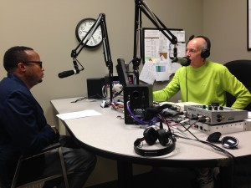
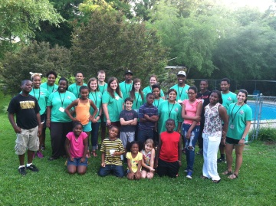
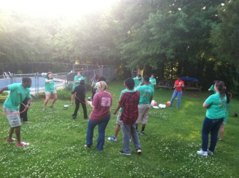
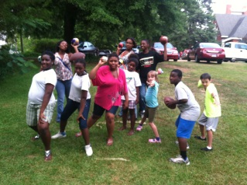
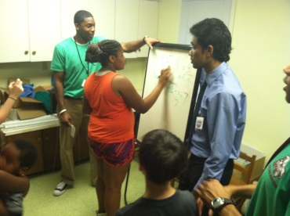
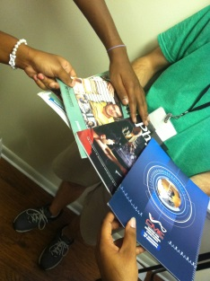
Rod Holmes promoting BB4K at 100.9 Super Talk MS with Jim Ellis
Community and Facilitator Training
These training sessions are for those who are looking to help eradicate poverty in the Oktibbeha County area. Both classes will be conducted by Bobbie Weatherly, on September 16th at the Starkville Sportsplex. The One-day community training will be the first half of the day, 8:00 a.m. – 2:30 p.m., and the Facilitator training will be the second half of the day, 3:00 p.m. – 5:00 p.m. It is $50 for each participant. For more information on the event or if you would like to participate contact Starkville Bridges at bridgesoutofpoverty@gmail.com or 662-617-4531.

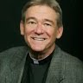
Bobbie Weatherly
Robert H. Weatherly, Sr., “Bobby”, is a native of Pontotoc, MS, and now lives in Vicksburg, MS with his wife Dannie. They have two children and one grandson. Bobby has a BS degree in Business from the College of Business and Industry at Mississippi State University, and the professional designation, Chartered Financial Consultant, awarded by the American College. He is a self-employed financial planner and investment adviser. In 2003, Bobby was ordained to the Deaconate in the Episcopal Diocese of Mississippi after completing a three year program of formation and formal theological education. Bobby is, also, a certified trainer for the Bridges out of Poverty initiative(s) in Mississippi. With his extensive background he will be the most suitable and capable Training conductor for both the One-Day Community and Facilitator trainings.

For more information, contact Bobby at bobbyweatherly@gmail.com.

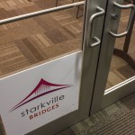

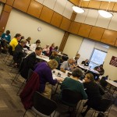
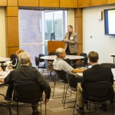
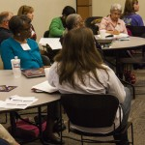
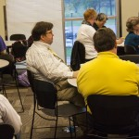
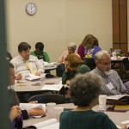
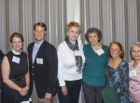
Ways you can contribute

Many have asked how they can participate in this initiative, so here are some of the ways that you can help:

Publicity: Writing press releases, taking photos of activities, and coordinating with the media to get the word out about what Starkville Bridges is doing.
Social Media: Anyone who likes following social media might enjoy maintaining our Facebook and Twitter pages.
Become a certified Bridges trainer so we have someone here in our area that can go into businesses, health care, education, and law enforcement communities to help educate our middle class first responders about the mental models of poverty. Funds are available to pay for training.
Speaker’s Bureau: We would love to have multiple volunteers who can address civic clubs and help organizations install Bridges within their organizations.
Event planning: For those who love to entertain, we need an event coordinator for the Soiree, Community Training, and other events.
Praying for our work, that it be pleasing in the sight of God.
Mentoring an under-resourced individual from our community.
Facilitating a Getting Ahead class.

Queen Brown, our student worker, is also a full-time student and is only here for limited hours during the week, so anyone willing to volunteer in these areas will be greatly appreciated! If interested contact us at: (662)-617-4531 or bridgesoutofpoverty@gmail.com

Starkville Bridges is a 501 (c) (3) tax exempt, non-profit organization.
Donations can be made on www.starkvillebridges.com or by mail to P.O. Box 5201, Miss State, MS 39762
Closing Remarks from the President
First and foremost, I would like to thank Lynn Phillips-Gaines for her leadership and support on behalf of Starkville Bridges since its inception in June 2011. Following her as Board President has shown me just how much above and beyond the call of service she has given to this organization. Thank you, Lynn, for your years of friendship and your spirit of ministry to our community.
I look forward to a bright future for Starkville Bridges and our community at large, as we seek understanding of and solutions to generational poverty. As you can see in this newsletter, our BB4K summer program has begun and is in partnership with the Starkville Boys and Girls Club. We are also hosting a One-Day Community and Facilitator Training event at the Starkville Sportsplex on September 16 beginning at 8:00 a.m. This training is important to those of us who grew up in the middle class to get a handle on what poverty looks like from the inside. This understanding is, in my opinion, basic to moving forward to creating an economically and socially sustainable community. For me, my well-being in the context of community is tied directly to the well-being of my neighbor.

This is the reason that I am involved with Starkville Bridges.
Lastly, I would like to thank everyone who has been involved with Starkville Bridges during this time of inception and growth. There has been a lot of hard work and time invested and I am profoundly grateful for all of you.

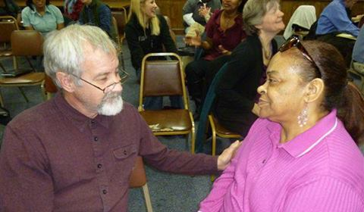
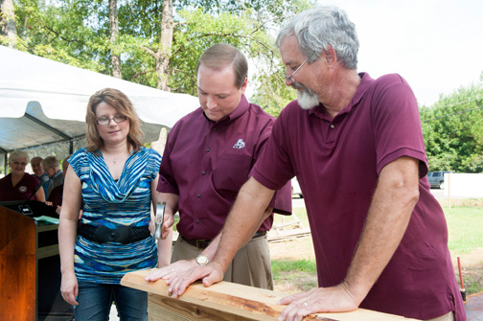
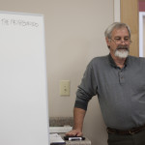
John Breazeale with a Starkville Bridges participate
John with Mississippi State University President, Dr. Mark Keenum
John facilitating a Getting Ahead in a Just Getting’ By World class

